Mustang project developer documentation
Jochen Stärk
For Mustangproject 1.2.0, 2015-10-15
http://www.mustangproject.org
Inhaltsverzeichnis
Mustang project developer documentation 1
New build 1
Release 2
After the release 3

New build

A section in Maven's settings.xml is needed, in Linux (and MacOS) that's at ~/.m2/settings.xml
As „servers“, enter the following
<servers>
<server>
<id>github</id>
<password>GITHUB-TOKEN</password>
</server>
</servers>
The password is generated on github.
See the following screenshot:

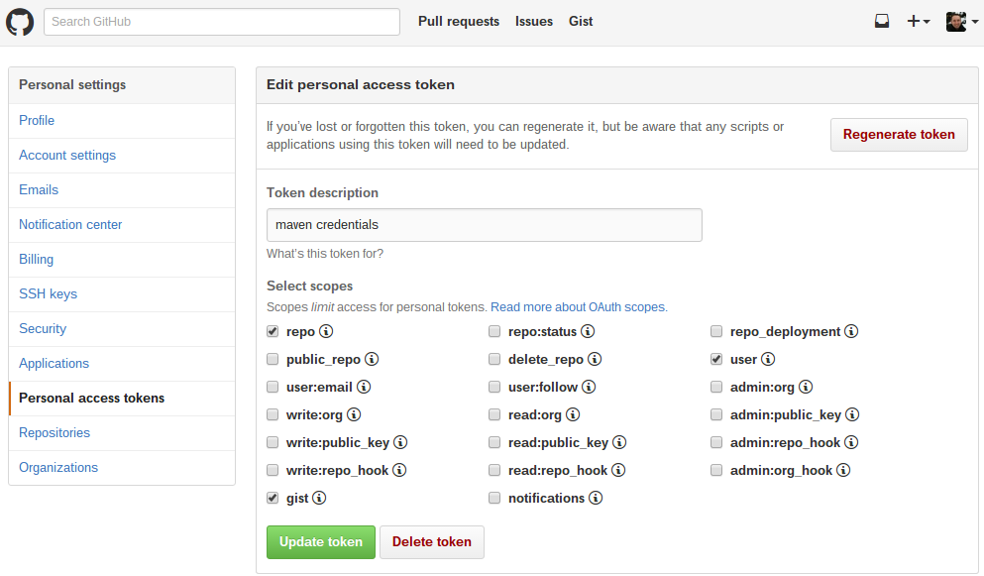
Sign in in GitHub and click on the profile picture -> Settings. Now just generate a new token and set the checkboxes from the screenshot. The Token-ID is the passwort.

Release
Now to the release:
You will need a git client on the console, if that's available can e.g. be checked with "git --version" .
Change to the project directory and run "mvn clean install" . If that works you can prepare the release with "mvn release:prepare" and enter the version numbers. Don't forget that mustangproject is a subproject and the version number will be the second or third to be asked for.
After that is through you can create a new release via "mvn release:perform". This will also update the maven repo.
Afterwards you can access the release page and update the documentation, e.g. upload the jar, the jar javadoc and ZugferdDev. You can also enter a changelog and a better title.

After the release
freshcode.club
hschlosser

